GLAB: Outlook.com Calendar

# Introduction

Another essential part of a corporate work environment is time management. Appearing, at times, like more of an art than a science, Outlook’s calendar is the go-to tool for time management.

This lab will familiarize you with various Outlook calendar features and options. Create events and learn how Outlook helps to manage your time and helps you communicate with peers like a pro.

In parts 2 and 3 of this lab, you will require an email address of a fellow peer**.** If you have not already done so, return to **the Discussion: Share Microsoft Account**  on Canvas to retrieve and record an email address to utilize during this lab. Make sure to record their full name and @outlook.com email address.

**Note:** Microsoft 365 is constantly evolving. The exact steps and screenshots may differ from this lab.

# Objectives

* Explore the Calendar and create events.
* Share your calendar and schedule a meeting.

# Recommended Equipment

* A Windows computer with Internet access.
* The completion of the following labs:
  + GLAB 5.1.1: Sign Up for a Microsoft Account
  + GLAB 5.2.1: Add Contacts into Outlook
  + GLAB 5.2.2: Outlook.com Email

# Part 1: Explore the Calendar and create events.

## Step 1: Sign in to Outlook for the web.

* + 1. *Using a* ***web browser****, navigate to* [*https://outlook.live.com*](https://outlook.live.com)*.*
    2. *On the* ***Sign in*** *window, enter* ***your @outlook.com*** *account email address, and click on the* ***Next*** *button.  
       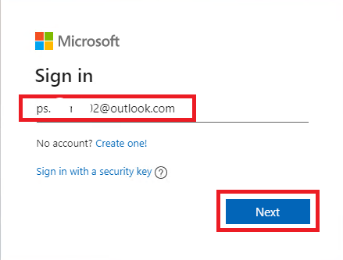*
    3. *Enter your* ***password*** *and click on the* ***Sign in*** *button.  
       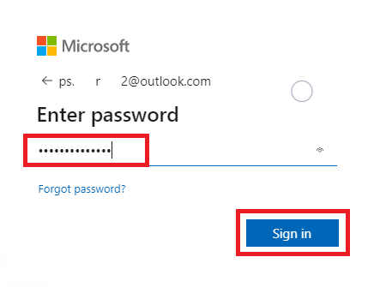*
    4. *Choose a Stay signed in option.  
       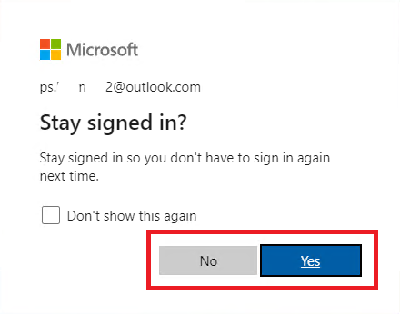*

## Step 2: Explore calendar features.

* + 1. *After you sign in, Outlook for the web will display your* ***Inbox*** *containing some welcome and promotional messages. Click on the* ***Calendar icon*** *on the vertical toolbar to the left.  
       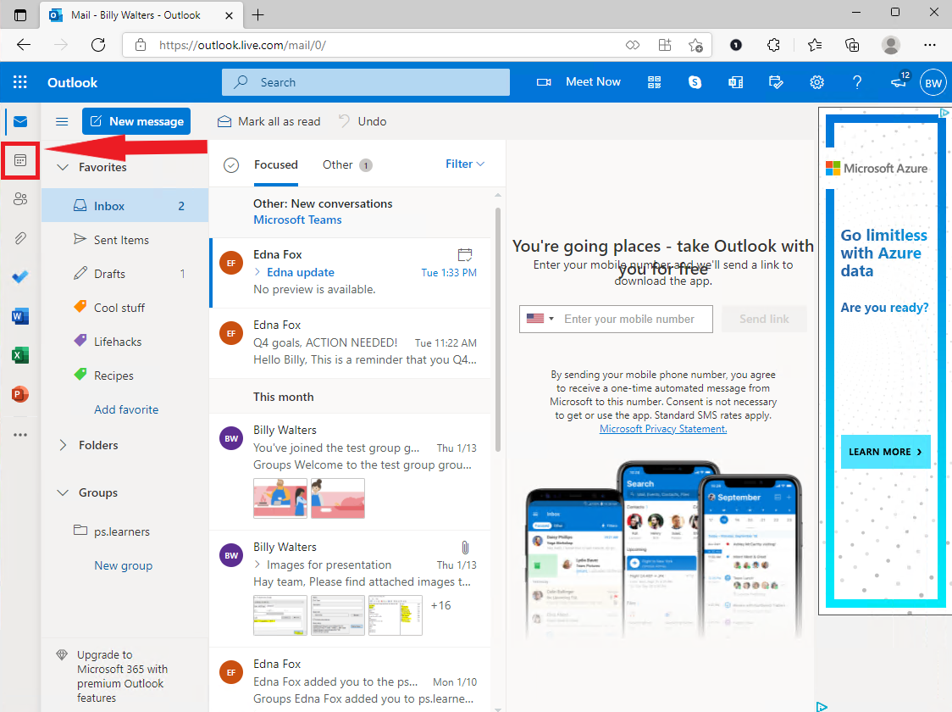*
    2. ***Experiment*** *with the different buttons and display options on the top toolbar.   
       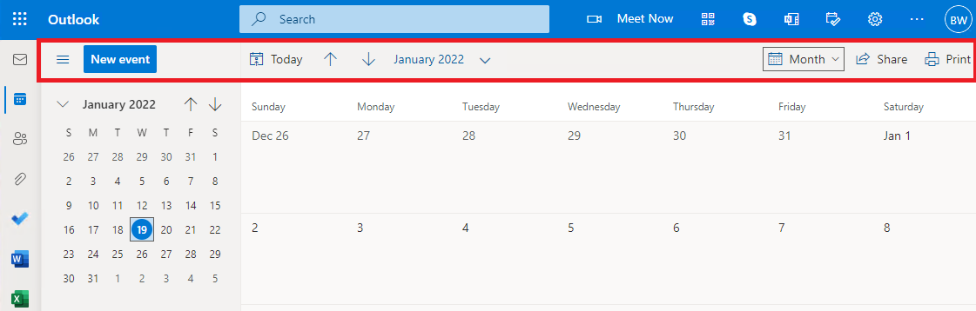*
    3. *Set the Calendar to display* ***three*** *days.*
    4. *Set the Calendar to display the* ***work week****.*
    5. *Click on the* ***weather icon*** *to display more detailed weather information. Use the* ***Edit locations*** *link to set the weather forecast to your location.  
       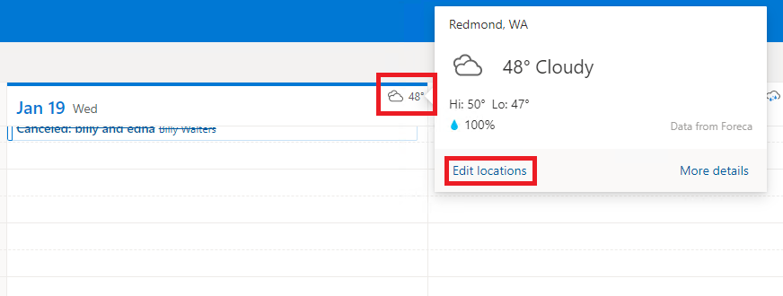*

## Step 3: Create an event.

* + 1. *Click on an* ***available time slot*** *in the future* ***or*** *click the* ***New event*** *button.   
       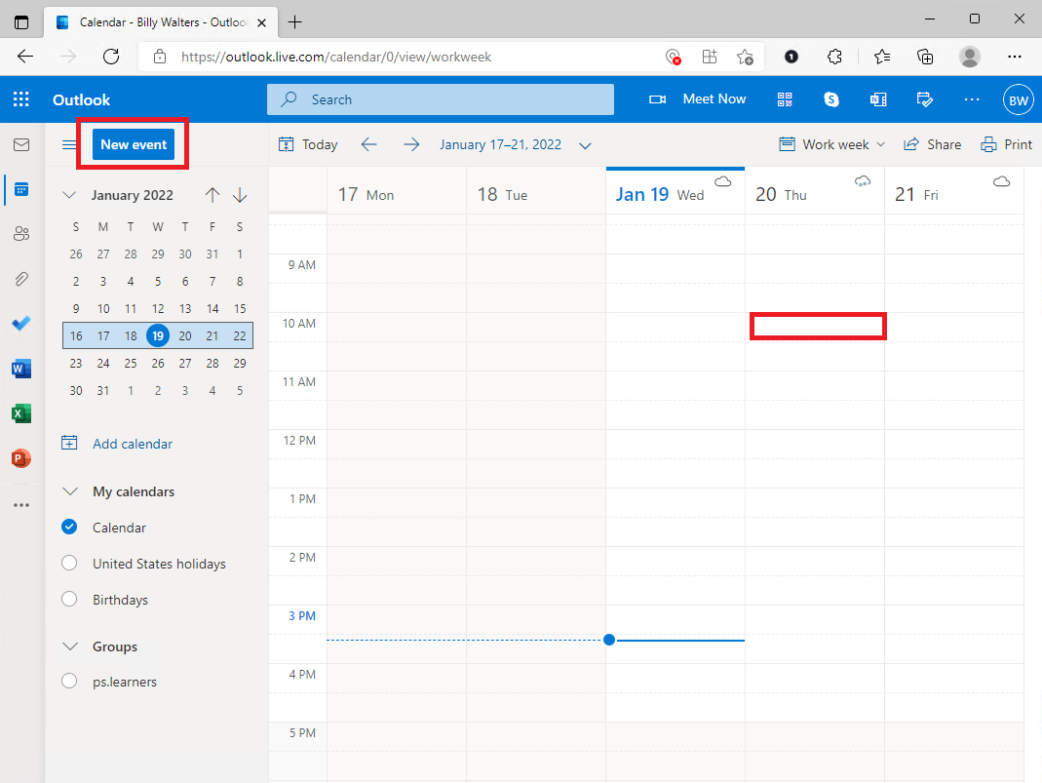*
    2. *On the* ***event dialog box****, schedule a future coffee break between* ***10 AM and 10:15 AM****. Select a* ***location*** *for the event. Have the event* ***repeat every weekday for the next month****. Set the reminder to go off* ***at the time of the event****. When you are done, click on the* ***Save*** *button.  
       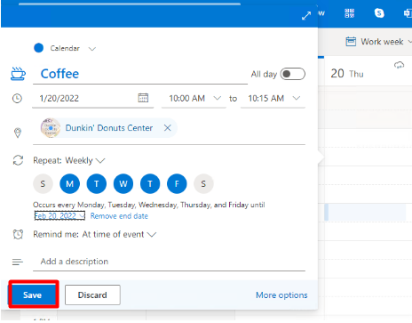*
    3. *Navigate to the* ***Month*** *view on your calendar and take note that the meeting has been created and appears on your calendar.*
    4. *Create the following events on your calendar:*

|  |  |  |  |  |  |  |
| --- | --- | --- | --- | --- | --- | --- |
| Title | Date | Start Time | End Time | Location | Repeat | Reminder |
| *Dentist* | *Sometime next week* | *You Choose* | *one hour* | *Set location* | *No* | *2 hours before* |
| *Grocery shopping* | *Sometime next week* | *You Choose* | *2 hours* | *Set location* | *Once a week for two months.* | *30 minutes before.* |
| *Study time* | *Sometime next week* | *You Choose* | *3 hours* | *Set location* | *every other day, not on the weekends for two weeks.* | *10 min before* |
| *Desktop support Job interview - in person.* | *A week from now* | *12:30 pm* | *1:30 pm* | *TEKsystems* | *No* | *1 hour before* |
| *Pet grooming* | *First Tuesday next month* | *3:30 PM* | *5:30 PM* | *Set location* | *Once a month for one year.* | *1 day before* |
| *Workout* | *Sometime next week* | *7:00 am* | *8:30 am* | *Set location* | *every other day, no end date.* | *At the time of the event.* |

## 

# Part 2: Share your calendar and schedule a meeting.

In part 2, you will share your calendar with a peer. Once you can view your peer’s available time slots, you will set up a meeting and send an invite. If you do not receive an invite to a shared calendar, carefully review the steps below to prepare for a discussion.

## Step 1: Share your calendar.

* + 1. *Once logged into Outlook, under the* ***Calendar*** *section, click on the* ***Share*** *button.  
       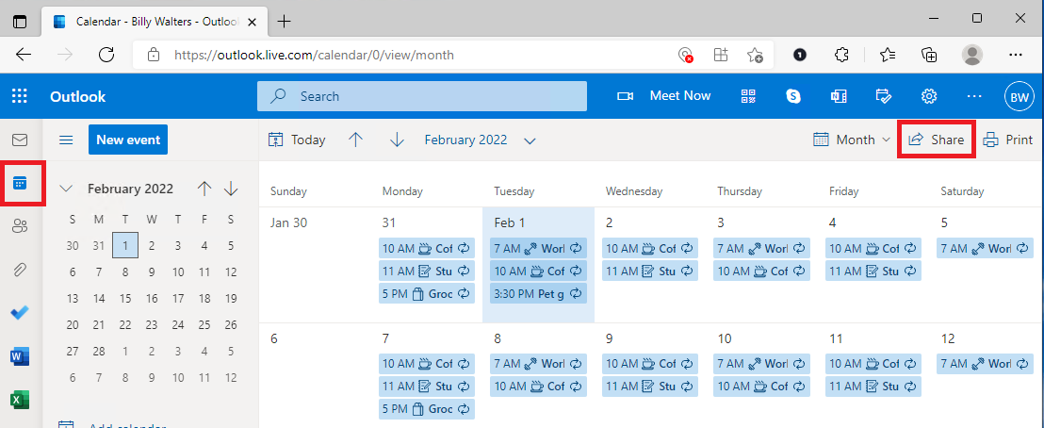*
    2. *On the* ***Sharing and permissions*** *window, start typing* ***ps*** *into the* ***Enter an email address or contact name*** *text field. Outlook will scan your contacts list and display matching entries.   
       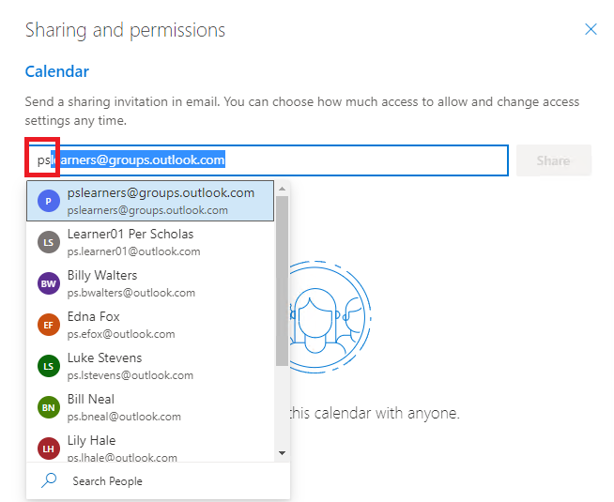*
    3. *Select your* ***peer’s email*** *from the list. If your peer’s email is not on the list, type the entire address into the text field. Next, ensure that the permissions are set to* ***Can view all details,*** *and click on the* ***Share*** *button.***Note:** You can share your calendar with multiple people and revoke sharing any time by clicking on the garbage can icon.  
       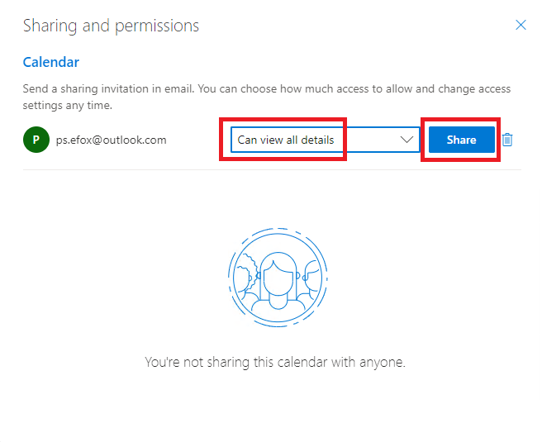
    4. *Close the* ***Sharing and permissions*** *window.*
    5. *To* ***accept*** *your peer’s invitation to view their calendar, navigate to your email’s* ***inbox****. Find and click on your peer’s* ***invitation*** *email. In the email’s content pane, click the* ***Accept*** *button.  
       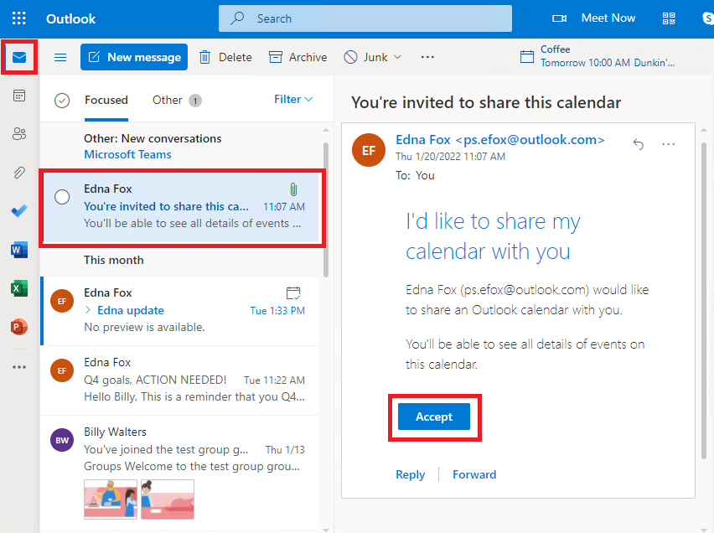*
    6. *To view your peer’s calendar, click the* ***View calendar*** *button in the email’s content pane.  
       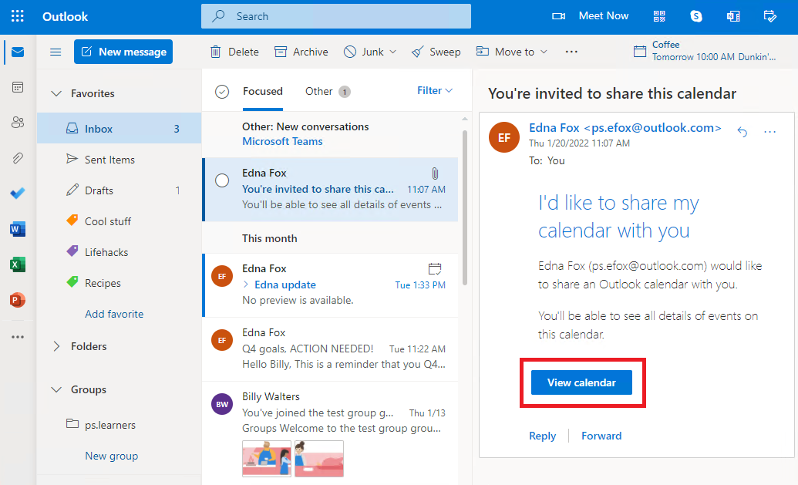*
    7. *Outlook will* ***display*** *events on your peer’s calendar in* ***addition*** *to your calendar events. You can* ***toggle*** *this display by clicking on the* ***checkmark*** *next to your peer’s calendar under the* ***Other calendars*** *section.  
       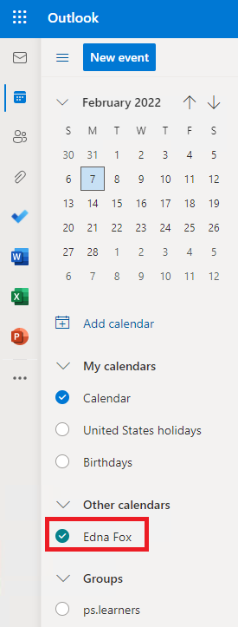*

## Step 2: Create a meeting.

In step 2, you will set up a meeting with your peer. Microsoft 365 has a tool named Teams for this purpose. While you are setting up a meeting with your peer, your peer will be setting up a meeting with you. Note that you should have two meetings at the end of this section — one that you set up and another that your peer set up. Again, if you have not received an invite to complete this step of the guided lab, review the directions carefully on how to schedule a meeting with other attendees.

* + 1. *On your* ***Outlook calendar****, switch to* ***Day*** *view (you can activate the* ***Split view*** *option if you like. The Split view option is active on the image below). While considering your peer’s events, find some free time* ***later today*** *to schedule a 30-minute* ***meeting.*** 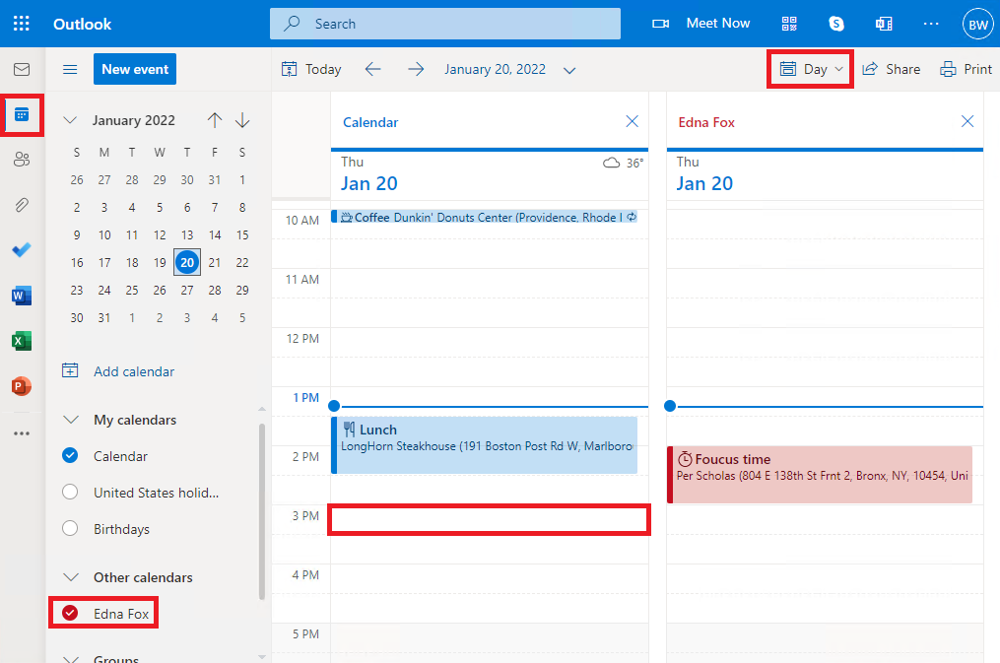
    2. *Click on the* ***available*** *time slot. Enter* ***your name / peer’s name*** *as the* ***title****. Ensure that the* ***time settings*** *are correct, the event* ***does not repeat****, and the* ***15 minutes reminder*** *is set. Next, click on the* ***More options*** *link.  
       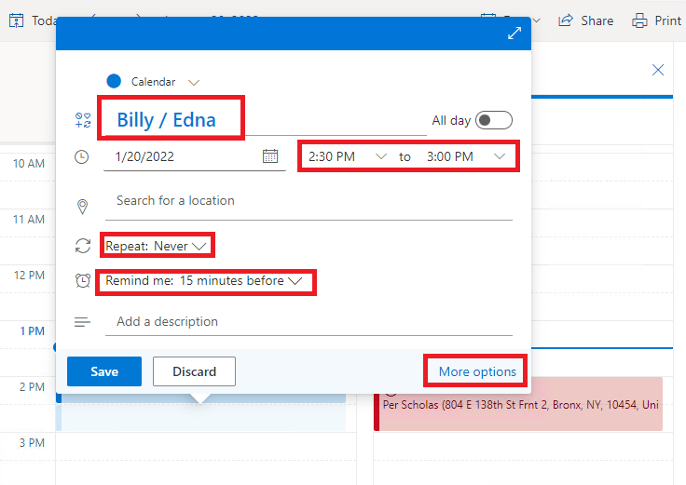*
    3. *On the* ***extended event options*** *window, click on the* ***Invite attendees*** *text field and select your* ***peer’s contact*** *from the list. (If the contact does not pop up, enter your peer’s email address.)   
       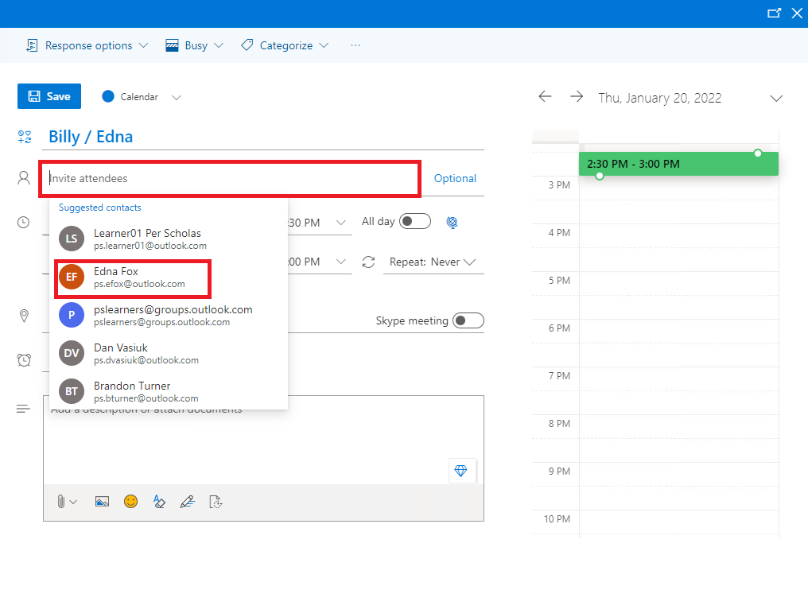*
    4. *Select* ***Save.***
    5. *When your peer sets up a meeting, an* ***incoming email*** *will notify you. Navigate to your email’s* ***inbox****, locate and click on the* ***meeting invitation****. Click the* ***RSVP*** *button to select your* ***response to the invite*** *on the email content pane.   
       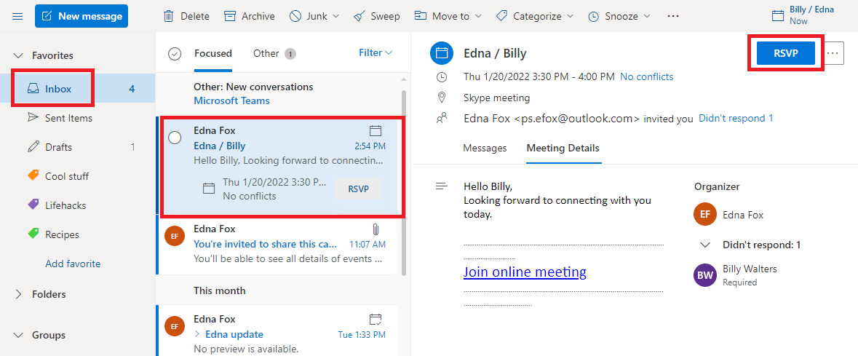*
    6. *From the response options, click on the* ***checkmark*** *button to let your peer know you will be attending the meeting. Note the* ***Add a message*** *option.   
       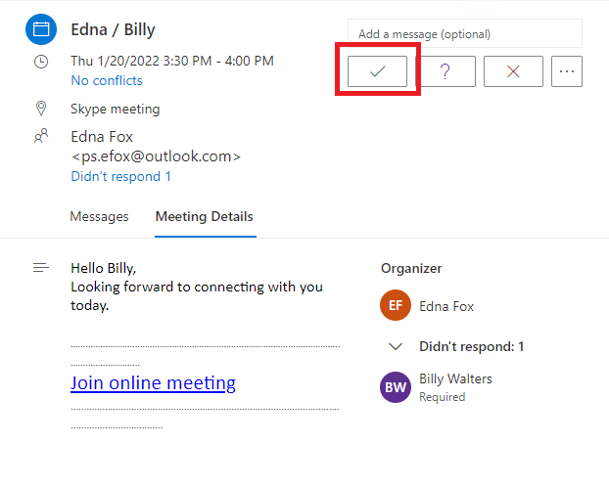*
    7. *When your peer sends you a meeting invite, you will receive an* ***email*** *notification. Navigate to your email’s inbox,* ***locate the invitation*** *to the meeting and click on the* ***RSVP*** *button. Click on the* ***Yes*** *button to confirm attending the meeting.   
       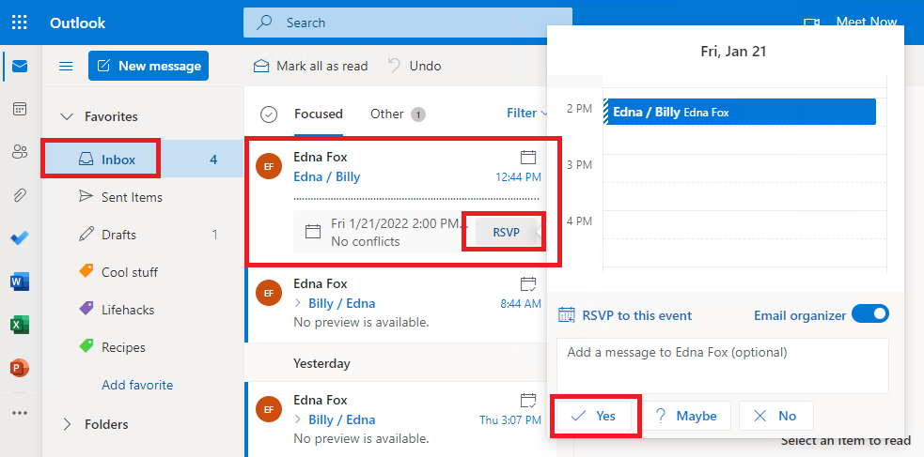*
    8. *The event will also show on your calendar.* ***Another way*** *to respond is to click on the* ***meeting*** *event and select* ***Yes*** *from the* ***Yes, I’ll attend*** *dropdown menu.  
       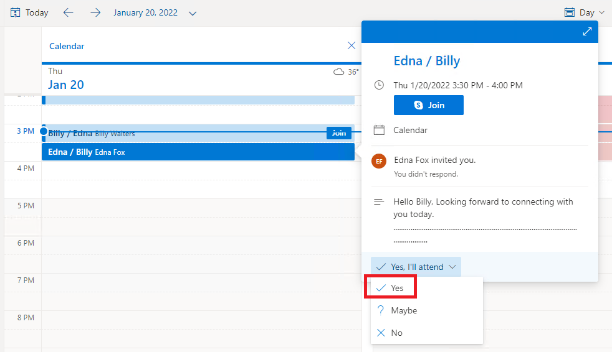*
    9. *Add a message, if you like, and click on the* ***Send*** *button.  
       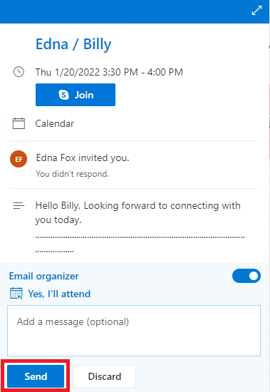*

## Part 3: Reflection.

If you have not done so already, download a copy of the Guided Lab and save it in a location on your laptop/desktop that can be easily accessed. You can also choose to save it to your Microsoft OneDrive. Once you have completed the Reflection questions, follow the instructions for submission.

* + 1. How does utilizing organization tools, such as folders and categories, help you manage your emails in Microsoft Outlook?

|  |
| --- |
| *I am pretty forgetful so I love being able to categorize and sync calendars/emails between laptops and my phone so I can get reminders for tasks.* |

* + 1. After reviewing the tools in this lab, what are you most excited about implementing?

|  |
| --- |
| *I am excited to get reacquainted with 365 as I have previously used this is almost of my roles. Mainly looking forward to learning more about PowerBi and Excel.* |

## Part 4: Submission.

1. When you have completed the lab, including responding to the reflection questions, submit a copy of the lab on Canvas in a PDF format to have the task marked as complete.
2. Suggested labeling of the pdf would be ***first initial.last name. GLAB #***
   1. Example: j.smith.GLAB 5.3.1